The Annual Quality Assurance Report (AQAR) of the IQAC

Part – A

AQAR for the year (for example 2013-14)
2015-16

1. Details of the Institution
1.1 Name of the Institution
Dr. Babasaheb Ambedkar Mahavidyalaya
Bar. Tatyasaheb Mane Vidyanagar
1.2 Address Line 1

Address Line 2
Peth-Vadgaon, Tal. Hatkanangale
Dist. Kolhapur
City/Town

State
Maharashtra

Pin Code
416112

Institution e-mail address
bacpvd@yahoo.co.in
0230-2471086
Contact Nos.
Prin. Dr. Sarjerao V. Padmakar
Name of the Head of the Institution:

Tel. No. with STD Code:
0230-2471086
Mobile:
+919623243104

Name of the IQAC Co-ordinator:
Prof. Ramesh M. Mirajkar
+919823561930
Mobile:
baciqac@gmail.com
IQAC e-mail address:
MHCOGN 11152
1.3 NAAC Track ID (For ex. MHCOGN 18879)
EC(SC)/06/RAR/ 027 dated 01-05-2015
1.4 NAAC Executive Committee No. & Date:
(For Example EC/32/A&A/143 dated 3-5-2004.
This EC no. is available in the right corner- bottom
of your institution’s Accreditation Certificate)
www.ambedkarcollege.co.in
1.5 Website address:
http://www.ambedkarcollege.co.in/AQAR2015-16.doc
Web-link of the AQAR:
For ex. http://www.ladykeanecollege.edu.in/AQAR2012-13.doc
1.6 Accreditation Details
Sl. No. | Cycle | Grade | CGPA | Year of Accreditation | Validity Period
1 | 1st Cycle | B | 2.71 | 2004 | 5 YEARS
2 | 2nd Cycle | B | 2.01 | 2015 | 5 YEARS
3 | 3rd Cycle
4 | 4th Cycle

01/02/2007
1.7 Date of Establishment of IQAC : DD/MM/YYYY

1.8 Details of the previous year’s AQAR submitted to NAAC after the latest Assessment and Accreditation by NAAC ((for example AQAR 2010-11submitted to NAAC on 12-10-2011)
- AQAR__________28-09-2012 __________________2011-2012
- AQAR__________24-10-2013 __________________2012-2013
- AQAR__________27-09-2014 __________________2013-2014
- AQAR__________30-10-2015_________________ 2014-2015
1.9 Institutional Status
√

University State Central Deemed Private
√

Affiliated College Yes No
Constituent College Yes No

√

Autonomous college of UGC Yes No

√

√

Regulatory Agency approved Institution Yes No
(eg. AICTE, BCI, MCI, PCI, NCI)
√

Type of Institution Co-education Men Women

√

Urban Rural Tribal

√

√

√

Financial Status Grant-in-aid UGC 2(f) UGC 12B

Grant-in-aid + Self Financing Totally Self-financing
√

1.10 Type of Faculty/Programme
√

Arts Science Commerce Law
√

PEI (Phys Edu) TEI (Edu) Engineering Health Science

Management

BCA
Others (Specify)
Shivaji University, Kolhapur (M.S.)
1.11 Name of the Affiliating University (for the Colleges)

1.12 Special status conferred by Central/ State Government-- UGC/CSIR/DST/DBT/ICMR etc
Autonomy by State/Central Govt. / University
NA
NA

University with Potential for Excellence UGC-CPE
NA

NA

NA

DST Star Scheme UGC-CE
NA

NA

UGC-Special Assistance Programme DST-FIST
NA

Nil
UGC-Innovative PG programmes Any other (Specify)

UGC-COP Programmes
Yes

2. IQAC Composition and Activities
2.1 No. of Teachers
5
2.2 No. of Administrative/Technical staff
1
2.3 No. of students
2
2.4 No. of Management representatives
2
1
2.5 No. of Alumni
2. 6 No. of any other stakeholder and
1
community representatives
1
2.7 No. of Employers/ Industrialists
1
2.8 No. of other External Experts
2.9 Total No. of members
14
2.10 No. of IQAC meetings held 02
2.11 No. of meetings with various stakeholders: Faculty
04
02
01
00
01
Non-Teaching Staff Alumni Others
00
Students

√
2.12 Has IQAC received any funding from UGC during the year? Yes No
--
If yes, mention the amount
2.13 Seminars and Conferences (only quality related): Nil
(i) No. of Seminars/Conferences/ Workshops/Symposia organized by the IQAC Level

Total Nos. International National State Institution

(ii) Themes

2.14 Significant Activities and contributions made by IQAC
Motivated and given guidance to faculty for reference books publication.

2.15 Plan of Action by IQAC/Outcome
The plan of action chalked out by the IQAC in the beginning of the year towards quality
enhancement and the outcome achieved by the end of the year *

Plan of Action | Achievements
- To prepare AQAR.  - To motivate faculty to write and publish Research Papers.  - To motivate faculty to write and publish Text/Reference books. | - AQAR is prepared and sent.  - Faculty has written and published Research Papers in quality journals.  - Two faculty members have written books. A member has published book and another member has communicated his book for national level publication.
* √ Attach the Academic Calendar of the year as Annexure.
2.16 Whether the AQAR was placed in statutory body Yes No
√

Management Syndicate Any other body
√

Provide the details of the action taken
Management has approved the draft.

Part – B
Criterion – I

1. Curricular Aspects

1.1 Details about Academic Programmes
Level of the Programme | Number of existing Programmes | Number of programmes added during the year | Number of self-financing programmes | Number of value added / Career Oriented programmes
PhD | 0 | 0 | 0 | 0
PG | 0 | 0 | 0 | 0
UG | 3 | 0 | 2 | 0
PG Diploma | 0 | 0 | 0 | 0
Advanced Diploma | 1 | 0 | 0 | 0
Diploma | 1 | 0 | 1 | 0
Certificate | 1 | 0 | 1 | 0
Others | 0 | 0 | 0 | 0
Total | 6 | 0 | 4 | 0

Interdisciplinary | - | - | - | -
Innovative | - | - | - | -

1.2 (i) Flexibility of the Curriculum: CBCS/Core/Elective option / Open options
(ii) Pattern of programmes:
Pattern | Number of programmes
Semester | 06
Trimester | --
Annual | --

1.3 Feedback from stakeholders* Alumni Parents Employers Students
√

√

-
√

(On all aspects)
-
√

-
Mode of feedback : Online Manual Co-operating schools (for PEI)
*Please provide an analysis of the feedback in the Annexure

1.4 Whether there is any revision/update of regulation or syllabi, if yes, mention their salient aspects.
After three years syllabi is revised.

1.5 Any new Department/Centre introduced during the year. If yes, give details.
Yes. Distance Centre of Shivaji University, Kolhapur.

Criterion – II
2. Teaching, Learning and Evaluation
2.1 Total No. of permanent faculty
Total | Asst. Professors | Associate Professors | Professors | Others
16 | 08 | 08 | Nil | -
03
2.2 No. of permanent faculty with Ph.D.
2.3 No. of Faculty Positions Recruited (R) and Vacant (V) during the year
Asst. Professors |  | Associate Professors |  | Professors |  | Others |  | Total
R | V | R | V | R | V | R | V | R | V
00 | 05 | - | - | - | - | - | - | 00 | 05

- -
-
12
2.4 No. of Guest and Visiting faculty and Temporary faculty

2.5 Faculty participation in conferences and symposia:

No. of Faculty | International level | National level | State level
Attended Seminars/ Workshops | 04 | 04 | 08
Presented papers | 04 | 04 | 08
Resource Persons | - | - | 07

2.6 Innovative processes adopted by the institution in Teaching and Learning:
Use of ICT, PPT, Study tours, Questionnaire, Use of pictures and group formation.

182

2.7 Total No. of actual teaching days
during this academic year
2.8 Examination/ Evaluation Reforms initiated by
Nil
the Institution (for example: Open Book Examination, Bar Coding,
Double Valuation, Photocopy, Online Multiple Choice Questions)
-
01
-
2.9 No. of faculty members involved in curriculum
restructuring/revision/syllabus development
as member of Board of Study/Faculty/Curriculum Development workshop
83 %
2.10 Average percentage of attendance of students

2.11 Course/Programme wise distribution of pass percentage: Data is not available.

Title of the Programme | Total no. of students appeared | Division
Title of the Programme | Total no. of students appeared | Distinction % | I % | II % | III % | Pass %
BA-III | 167 | 5.69 | 13.82 | 58.53 | 0.81 | 73.65
BCOM-III | 135 | 1.47 | 24 | 61 | 1.47 | 50.37
BCA-III | 22 | 9.09 | 54.54 | 27.27 | 9.09 | 50.00

2.12 How does IQAC Contribute/Monitor/Evaluate the Teaching & Learning processes:
IQAC monitors teaching and learning process. The meetings are held on various issues. The decisions are taken in the meetings are implemented.
2.13 Initiatives undertaken towards faculty development
Faculty / Staff Development Programmes | Number of faculty  benefitted
Refresher courses | Nil
UGC – Faculty Improvement Programme | Nil
HRD programmes | Nil
Orientation programmes | Nil
Faculty exchange programme | Nil
Staff training conducted by the university | 06
Staff training conducted by other institutions | Nil
Summer / Winter schools, Workshops, etc. | Nil
Others | Nil
2.14 Details of Administrative and Technical staff
Category | Number of Permanent  Employees | Number of Vacant  Positions | Number of permanent positions filled during the Year | Number of positions filled temporarily
Administrative Staff | 16 | 06 | - | 01
Technical Staff | - | - | - | -

Criterion – III
3. Research, Consultancy and Extension
3.1 Initiatives of the IQAC in Sensitizing/Promoting Research Climate in the institution
IQAC committee hold meetings from time to time. The teachers are encouraged to undertake research. Library facility is provided for them. Internet facility is also made available for surfing information required.

3.2 Details regarding major projects : Nil
 | Completed | Ongoing | Sanctioned | Submitted
Number
Outlay in Rs. Lakhs

3.3 Details regarding minor projects: Nil
 | Completed | Ongoing | Sanctioned | Submitted
Number
Outlay in Rs. Lakhs

3.4 Details on research publications
 | International | National | Others
Peer Review Journals | 09 | 01 | -
Non-Peer Review Journals | - | - | 05
e-Journals | - | - | -
Conference proceedings | - | - | -

3.5 Details on Impact factor of publications:
3.4052
3.4052

Nil
Nil
Range Average h-index Nos. in SCOPUS
3.6 Research funds sanctioned and received from various funding agencies, industry and other organisations: Nil
Nature of the Project | Duration  Year | Name of the  funding Agency | Total grant  sanctioned | Received
Major projects
Minor Projects
Interdisciplinary Projects
Industry sponsored
Projects sponsored by the University/ College
Students research projects
(other than compulsory by the University)
Any other(Specify)
Total

3.7 No. of books published i) With ISBN No. Chapters in Edited Books
03
-

ii) Without ISBN No.
Nil
3.8 No. of University Departments receiving funds from Nil

UGC-SAP CAS DST-FIST

DPE DBT Scheme/funds
3.9 For colleges Autonomy CPE DBT Star Scheme
Nil
Nil
Nil
INSPIRE CE Any Other (specify)
Nil
Nil
Nil
Nil
3.10 Revenue generated through consultancy

3.11 No. of conferences organized by the Institution: Nil
Level | International | National | State | University | College
Number | - | - | - | - | -
Sponsoring agencies | - | - | - | - | -
042
3.12 No. of faculty served as experts, chairpersons or resource persons
  - No. of collaborations: Nil

International National Any other
3.14 No. of linkages created during this year
Nil
3.15 Total budget for research for current year in lakhs : Nil
From Funding agency From Management of University/College
-
-
Total
-

3.16 No. of patents received this year: Nil
Type of Patent |  | Number
National | Applied
National | Granted
International | Applied
International | Granted
Commercialised | Applied
Commercialised | Granted

3.17 No. of research awards/ recognitions received by faculty and research fellows
Of the institute in the year: Nil
Total | International | National | State | University | Dist | College
- | - | - | - | - | - | -

3.18 No. of faculty from the Institution who are Ph. D. Guides and students registered under them
Nil

3.19 No. of Ph.D. awarded by faculty from the Institution
-

3.20 No. of Research scholars receiving the Fellowships (Newly enrolled + existing ones): Nil

Nil
Nil
JRF SRF Project Fellows Any other
Nil

3.21 No. of students Participated in NSS events:
25
Nil
University level State level
National level International level
Nil
Nil

3.22 No. of students participated in NCC events:
Nil

03
University level State level
National level International level
Nil

Nil
3.23 No. of Awards won in NSS:
Nil
University level State level
Nil
National level International level
Nil
Nil
3.24 No. of Awards won in NCC:
University level State level
Nil
Nil
National level International level
Nil
Nil
3.25 No. of Extension activities organized
-
-
University forum College forum
NCC NSS Any other
04
05
-

3.26 Major Activities during the year in the sphere of extension activities and Institutional Social Responsibility
- Start up India program organised
- Survey of non-school going children, Pulse-Polio Campaign
- Campaign of save daughter
- Voter awareness Rally

Criterion – IV

4. Infrastructure and Learning Resources
4.1 Details of increase in infrastructure facilities:
Facilities | Existing | Newly created | Source of Fund | Total
Campus area | 2o  Acres | - | - | 20
Class rooms | 23 | - | UGC/College | 23
Laboratories | 02 | - | - | 02
Seminar Halls | - | 01 | UGC/College | 01
No. of important equipments purchased (≥ 1-0 lakh) during the current year. | Nil | - | - | -
Value of the equipment purchased during the year (Rs. in Lakhs) | Nil | - | - | -
Others | - | - | - | -

4.2 Computerization of administration and library
Administration work, accounts and admission process have been computerized. Library is partially computerised.

4.3 Library services:
 | Existing |  | Newly added |  | Total
 | No. | Value | No. | Value | No. | Value
Text Books | 19574 | 2916526/- | - | - | 19574 | 2916526/-
Reference Books | 6633 | 2646567/- | 235 | 62907/- | 6668 | 2709474/-
e-Books | - | - | - | - | - | -
Journals | 27 | 8073/- | 30 | 40573/- | 57 | 48646/-
e-Journals | N List pac | 5000/- | N List pac | 5725/- | N List pac | 10725/-
Digital Database | - | - | - | - | - | -
CD & Video | 63 | - | - | - | 63 | -
Others (specify) | - | - | - |  | - | -

4.4 Technology up gradation (overall)
 | Total Computers | Computer Labs | Internet | Browsing Centres | Computer Centres | Office | Departments | Others
Existing | 48 | 01 | Yes | - | - | Yes | - | -
Added | - | - | - | - | - | - | - | -
Total | 48 | 01 | - | - | - | - | - | -

4.5 Computer, Internet access, training to teachers and students and any other programme for technology up gradation (Networking, e-Governance etc.)
NRC is kept open for staff and students

4.6 Amount spent on maintenance in lakhs : (approximately)
0.25
i) ICT
1.20
ii) Campus Infrastructure and facilities
0.00
iii) Equipments
2.15
iv) Others

03.60
Total :

Criterion – V

5. Student Support and Progression
5.1 Contribution of IQAC in enhancing awareness about Student Support Services
IQAC motivates faculty to organize activities, which are helpful to the students, such as remedial coaching, Statistics quiz etc.

5.2 Efforts made by the institution for tracking the progression
- University results are scrutinized
- Faculty performance scrutinized
- Staff meetings.

5.3 (a) Total Number of students
UG | PG | Ph. D. | Others
1085 | - | - | -

(b) No. of students outside the state
Nil
Nil
(c) No. of international students

Men Women
No | %
690 | 63.59
No | %
395 | 36.41
Last Year(2014-15) |  |  |  |  |  | This Year(2015-16)
General | SC | ST | OBC | Physically Challenged | Total | General | SC | ST | OBC | Physically Challenged | Total
802 | 218 | 02 | 162 | 02 | 1186 | 689 | 247 | 04 | 144 | 01 | 1085

Demand ratio: Nil Dropout: --
5.4 Details of student support mechanism for coaching for competitive examinations (If any)
Guest lectures are organised by Institution

26
No. of students beneficiaries
5.5 No. of students qualified in these examinations
--
--

--

--

NET SET/SLET GATE CAT
IAS/IPS etc State PSC UPSC Others
--

--

--

--

5.6 Details of student counselling and career guidance
One workshop is organized under the lead college activity.

No. of students benefitted
37

5.7 Details of campus placement- Nil
On campus |  |  | Off Campus
Number of Organizations Visited | Number of Students Participated | Number of Students Placed | Number of Students Placed

5.8 Details of gender sensitization programmes
Nil

5.9 Students Activities
5.9.1 No. of students participated in Sports, Games and other events
--
State/ University level National level International level
15
01

No. of students participated in cultural events
--
--
--
State/ University level National level International level
5.9.2 No. of medals /awards won by students in Sports, Games and other events
00
00
05
Sports : State/ University level National level International level
00
00
00
Cultural: State/ University level National level International level

5.10 Scholarships and Financial Support
 | Number of  students | Amount
Financial support from institution (S.A.) | 05 | 1100/-
Financial support from government | 216 | 3,22,058/-
Financial support from other sources | Nil | Nil
Number of students who received International/ National recognitions | Nil | Nil

5.11 Student organised / initiatives : Nil

Fairs : State/ University level National level International level

Exhibition: State/ University level National level International level
01
5.12 No. of social initiatives undertaken by the students

5.13 Major grievances of students (if any) redressed: Nil

Criterion – VI
6. Governance, Leadership and Management
6.1 State the Vision and Mission of the institution
Vision: “To provide the quality education to all, especially to the slum, rural and socio- economically deprived students to make them self reliant and responsible citizens of the nation.”
Mission: 1. To provide facilities for education: Secondary, college level, Technical, Physical and the like. 2. To provide facilities for education of the poor.

6.2 Does the Institution has a management Information System
Yes.

6.3 Quality improvement strategies adopted by the institution for each of the following:
6.3.1 Curriculum Development
There is little scope in it, as the curriculum is framed by the University. However the suggestions in regard to curriculum are given by faculty to the University. Some of our faculty are involved in the process of framing curriculum.

6.3.2 Teaching and Learning
- Innovative methods -internal evaluation, study tours, Statistics quiz, project works, seminars etc.
- Student centric teaching methodology
- Focus on interactive teaching methods

6.3.3 Examination and Evaluation
- Fair and impartial conduct of examinations.
- Provision to provide photocopies of answer books.
- Revaluation facility.
- Prompt and timely evaluation.

6.3.4 Research and Development
Faculty is motivated to undertake research work, such as publication of Books and Research papers.

6.3.5 Library, ICT and physical infrastructure / instrumentation
- Library fulfils the needs of readers and researchers.
- ICT facility is kept available. Physical infrastructure is fully utilized.
- Installation of Surveillance System with CC TV facility having 14 Cameras.

ICT for Office NRC, library.

6.3.6 Human Resource Management
- College timing is set
- Muster-biometric-machine
- Record of leaves
- Grant leave to participate in workshop/conferences etc.

6.3.7 Faculty and Staff recruitment
Yes, as per the rules of Shivaji University, Kolhapur and State Government.

6.3.8 Industry Interaction / Collaboration
Educational tours are arranged by Geography and Commerce departments.

6.3.9 Admission of Students
- First come first serve bases
- Fair and transparent admission process as per the university and government rules.

6.4 Welfare schemes for
Teaching | Nil
Non teaching | Nil
Students | Yes, Student Aid Fund, concession in fees for economically backward students

6.5 Total corpus fund generated
Rs: 65,290/-

(S.A. fund , college day, building fund)
Õ

6.6 Whether annual financial audit has been done Yes No

6.7 Whether Academic and Administrative Audit (AAA) has been done?
Audit Type | External |  | Internal
Audit Type | Yes/No | Agency | Yes/No | Authority
Academic | Yes | Shivaji University | Yes | College
Administrative | Yes | Government of Maharashtra | Yes | College

External administrative audit is conducted by state government through Joint Director Divisional office Kolhapur and the internal audit by the Office Superintendent.
6.8 Does the University/ Autonomous College declares results within 30 days? : N.A.
For UG Programmes Yes No

For PG Programmes Yes No

6.9 What efforts are made by the University/ Autonomous College for Examination Reforms?
Not Applicable

6.10 What efforts are made by the University to promote autonomy in the affiliated/ constituent colleges?
Not Applicable

6.11 Activities and support from the Alumni Association
We have organized Alumni meet and suggestions are taken for consideration.

6.12 Activities and support from the Parent – Teacher Association
We have organized Parent meet and suggestions are taken for consideration.

6.13 Development programmes for support staff
Staff deputed for participation in workshop on administrative work.

6.14 Initiatives taken by the institution to make the campus eco-friendly
- Tree plantation
- Maintenance of the college garden.
- Use of LED bulbs in the campus.

Criterion – VII
7. Innovations and Best Practices
7.1 Innovations introduced during this academic year which have created a positive impact on the functioning of the institution. Give details.
- Workshop organization under lead college scheme
- Celebration of Geography, Marathi and Rangnathan Day
- Tree plantation
- Blood donation

7.2 Provide the Action Taken Report (ATR) based on the plan of action decided upon at the
beginning of the year
- Tree plantation
- Awareness Rally
- Celebration of Day

7.3 Give two Best Practices of the institution (please see the format in the NAAC Self-study Manuals)
- Creation of research awareness among college students
- Creation of eco-friendly atmosphere in the college campus

*Provide the details in annexure (annexure need to be numbered as i, ii,iii)
7.4 Contribution to environmental awareness / protection
Environment awareness Rally.

7.5 Whether environmental audit was conducted? Yes No

Õ

7.6 Any other relevant information the institution wishes to add. (for example SWOT Analysis)
Nil
8. Plans of institution for next year
- To start science faculty
- To start Girls’ NCC

Name: Prof. Ramesh M. Mirajkar Name: Prin. Dr. Sarjerao V. Padmakar
______________sd/-_________________ ___________sd/-____________
Signature of the Coordinator, IQAC Signature of the Chairperson, IQAC

_______***_______

Annexure No. 1: Alumni Feedback
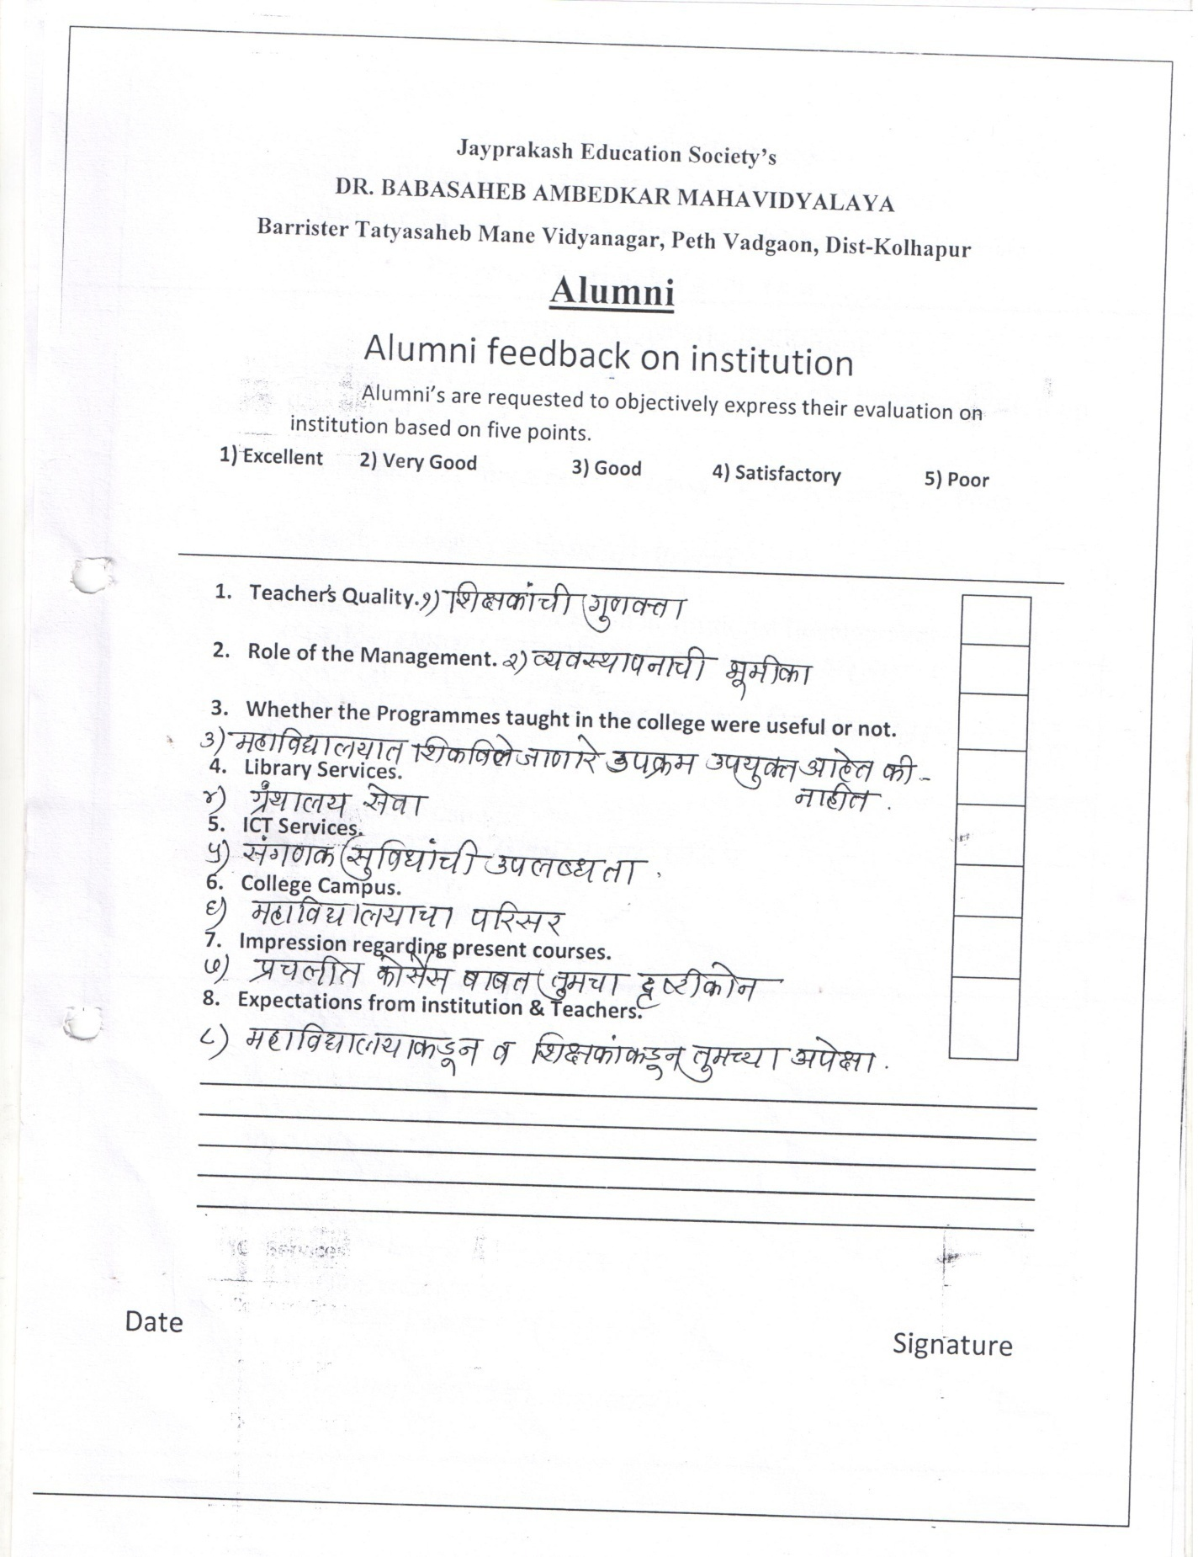

Annexure No. 2: Parents Feedback
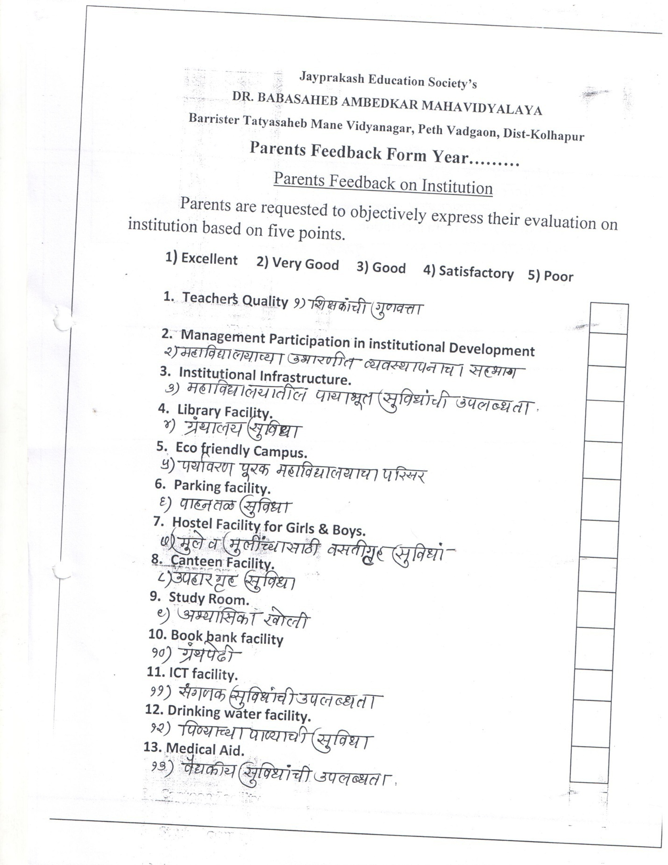
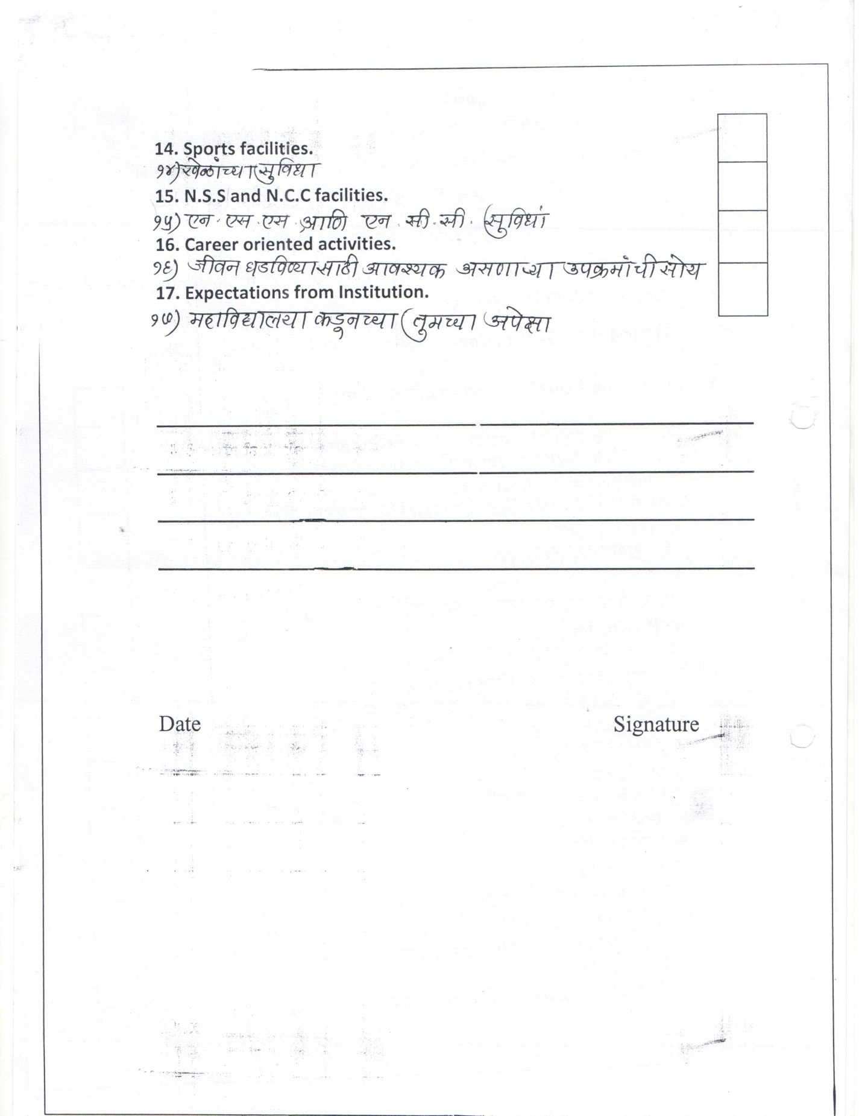

Annexure No. 3: Students Feedback on Teachers
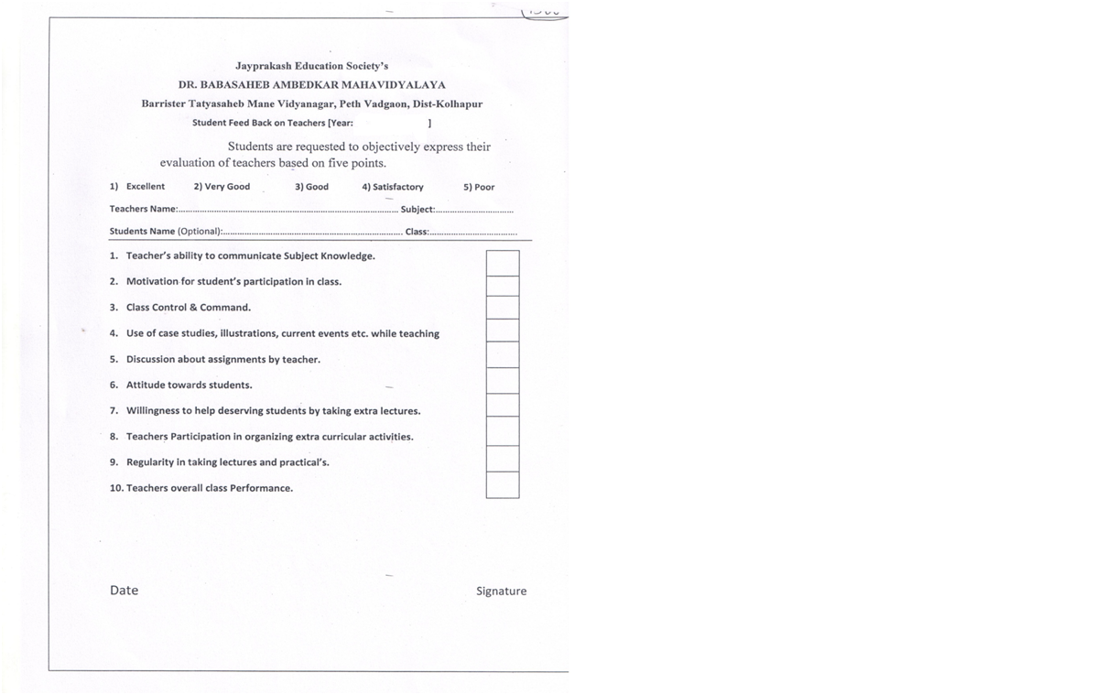

Annexure No. 4: Academic Calendar (2015-16)
Sr. No. | Month | Name of Activity
1 | June 2015 | 1. Staff meeting for Action plan of the year.  2. Preparation of time table  3. IQAC meeting  4. H.O.D.’s meeting
2 | July 2015 | 1. Inauguration of N.S.S.  2. Formation of committees  3. Sport meeting  4. N.C.C. meeting  5. Cultural meeting
3 | Aug. 2015 | 1. Tree plantation  2. Formation of Student’s Council  3. Celebration of Independence Day
4 | Sept. 2015 | 1. Celebration of N.S.S. Day  2. Arrangement of guest lectures on the behalf  of various committees
5 | Oct. 2015 | 1. Celebration of Gandhi Jayanti  2. IQAC meeting  3. First term end staff meeting
6 | Nov. 2015 | - Staff meeting
7 | Dec.2015 | 1. IQAC meeting  2. Mahanirvan Din of Dr. Babasaheb Ambedkar  3. Arrangement of guest lectures on the behalf  of various committees/clubs  4. Educational/Industrial trip  5. Sports activities  6. H.O.D.’s meeting
8 | Jan. 2016 | 1. Celebration of traditional day  2. College day  3. Cultural activities  4. Sports exam.  5. Celebration of Republic Day  6. Alumni Meet
9 | Feb. 2016 | 1. Statistics Quiz  2. Department activities  3. Sport meeting  4. N.C.C. meeting  5. Cultural meeting
10 | Mar.2016 | 1.N.S.S. Camp  2. University Exam.
11 | Apr. 2016 | 1. University Exam.  2. Celebration of Dr. Babasaheb Ambedkar Jayanti  3. IQAC meeting  4. Second term end staff meeting
12 | May 2016 | 1. Infrastructure development  2. University Exams.  3. Library Stock Taking- 15th May to 30th May 2016

Annexure No. 5: Best Practises
Best Practise No. 1
- Title:
“Creation of research awareness among college students”
- Goals :
- To create research awareness among students.
- To prepare research paper in research style.
- To present research paper in conference/seminar.
- To publish research bulletin of the Department every academic year.
- The Context:
Sociology department of our institution has tried to create research culture among department students. The faculty of this department has provided various research journals to students in English and Marathi medium for understanding nature of research and research papers. The valuable guidelines are given to active and research minded students for preparation of research papers, time to time.
- The Practice:
In order to create research culture, the faculty has motivated one ex-student and students of the department for preparation, and presentation of the research papers in various conferences and seminars. The department students tried to do their best and prepared research papers in English and Marathi medium.
- Evidence of the Success:
The department of sociology has published all papers of students’ by organizing small function to motivate the other students to do such type of activity. The name of departmental booklet is ‘WWWE Sociology’. The title gives the message…We want to enhance, We want to enlarge and We want to exchange Sociology. The booklet contains nine research papers out of which one research paper namely ‘Empowerment: Concept and its Meaning is prepared and presented by our alumni in International level Conference organized in Pune. Two papers presented in the Natioal Level conference organized by Vijaysingh Yadav College Peth Vadgaon, Dist. Kolhapur. The six research papers are prepared by other students has been included in the booklet.
- Problems Encountered and Resources Required:
The availability of fund is important problem. The provision of fund for such type of activity is necessary. Besides that, the international level journals, software like SPSS for data analysis is required for active research. Travelling expenses and registration fees of conferences/seminars should be given to concerning students.
- Contact Details:
Name of the Principle: Prin. Jaysing D. Sisal
Name of the Institution: Dr Babasaheb Ambedkar Mahavidyalaya, Peth Vadgaon Tal. Hatkanangale, Dist: Kolhapur, Maharashtra.
City: Peth Vadgaon,
Pin: 416112

Best Practise No. 2

- Title:
“Creation of eco-friendly atmosphere in the college campus”
- Goals:
To create healthy atmosphere in college campus.
- The Context:
NCC cadets, NSS volunteers and students of Geography Department along with college students and teaching and non teaching staff including management members of the institution jointly organized tree plantation programme on 1st July 2015. The department of Geography celebrated ‘Population Day’ by organizing tree plantation programme in college campus by taking oath that ‘one student one tree’ on 11th July 2015.
- Practice:
The NCC cadets, NSS volunteers and students’ of Geography department had taken initiative to make primary preparation of tree plantation programme. The actual programme is done on scheduled date and time. The planted trees were Teak-wood, Gulmohare, Pimpal, and Rat Killer.
- Evidence of the Success:
In all 120 teak wood, 02 Rat killer, 01 Pimpal and 01 Gulmohare plants are planted. This practice achieved grand success. Almost all the planted trees are in good condition. Students are taking care of planted trees by giving water time to time. The trees are growing and creating eco-friendly atmosphere in the college campus.
- Problems Encountered and Resources Required:
Sometimes, it is difficult to organize such programme due to unsatisfactory location. If strata are hard and soil is not good for trees, the entire efforts fail. In order to creation of echo-friendly atmosphere the necessary fertilizers should be given to trees. So there should be provision of fund.
- Contact Details:
Name of the Principle: Prin. Jaysing D. Sisal
Name of the Institution: Dr Babasaheb Ambedkar Mahavidyalaya,
Peth Vadgaon Tal. Hatkanangale, Dist: Kolhapur, Maharashtra.
City: Peth Vadgaon,
Pin: 416112.

--------------#########-------------

